2018 Colorado 500 Charities Fund Distributions
Total: $93,000.00
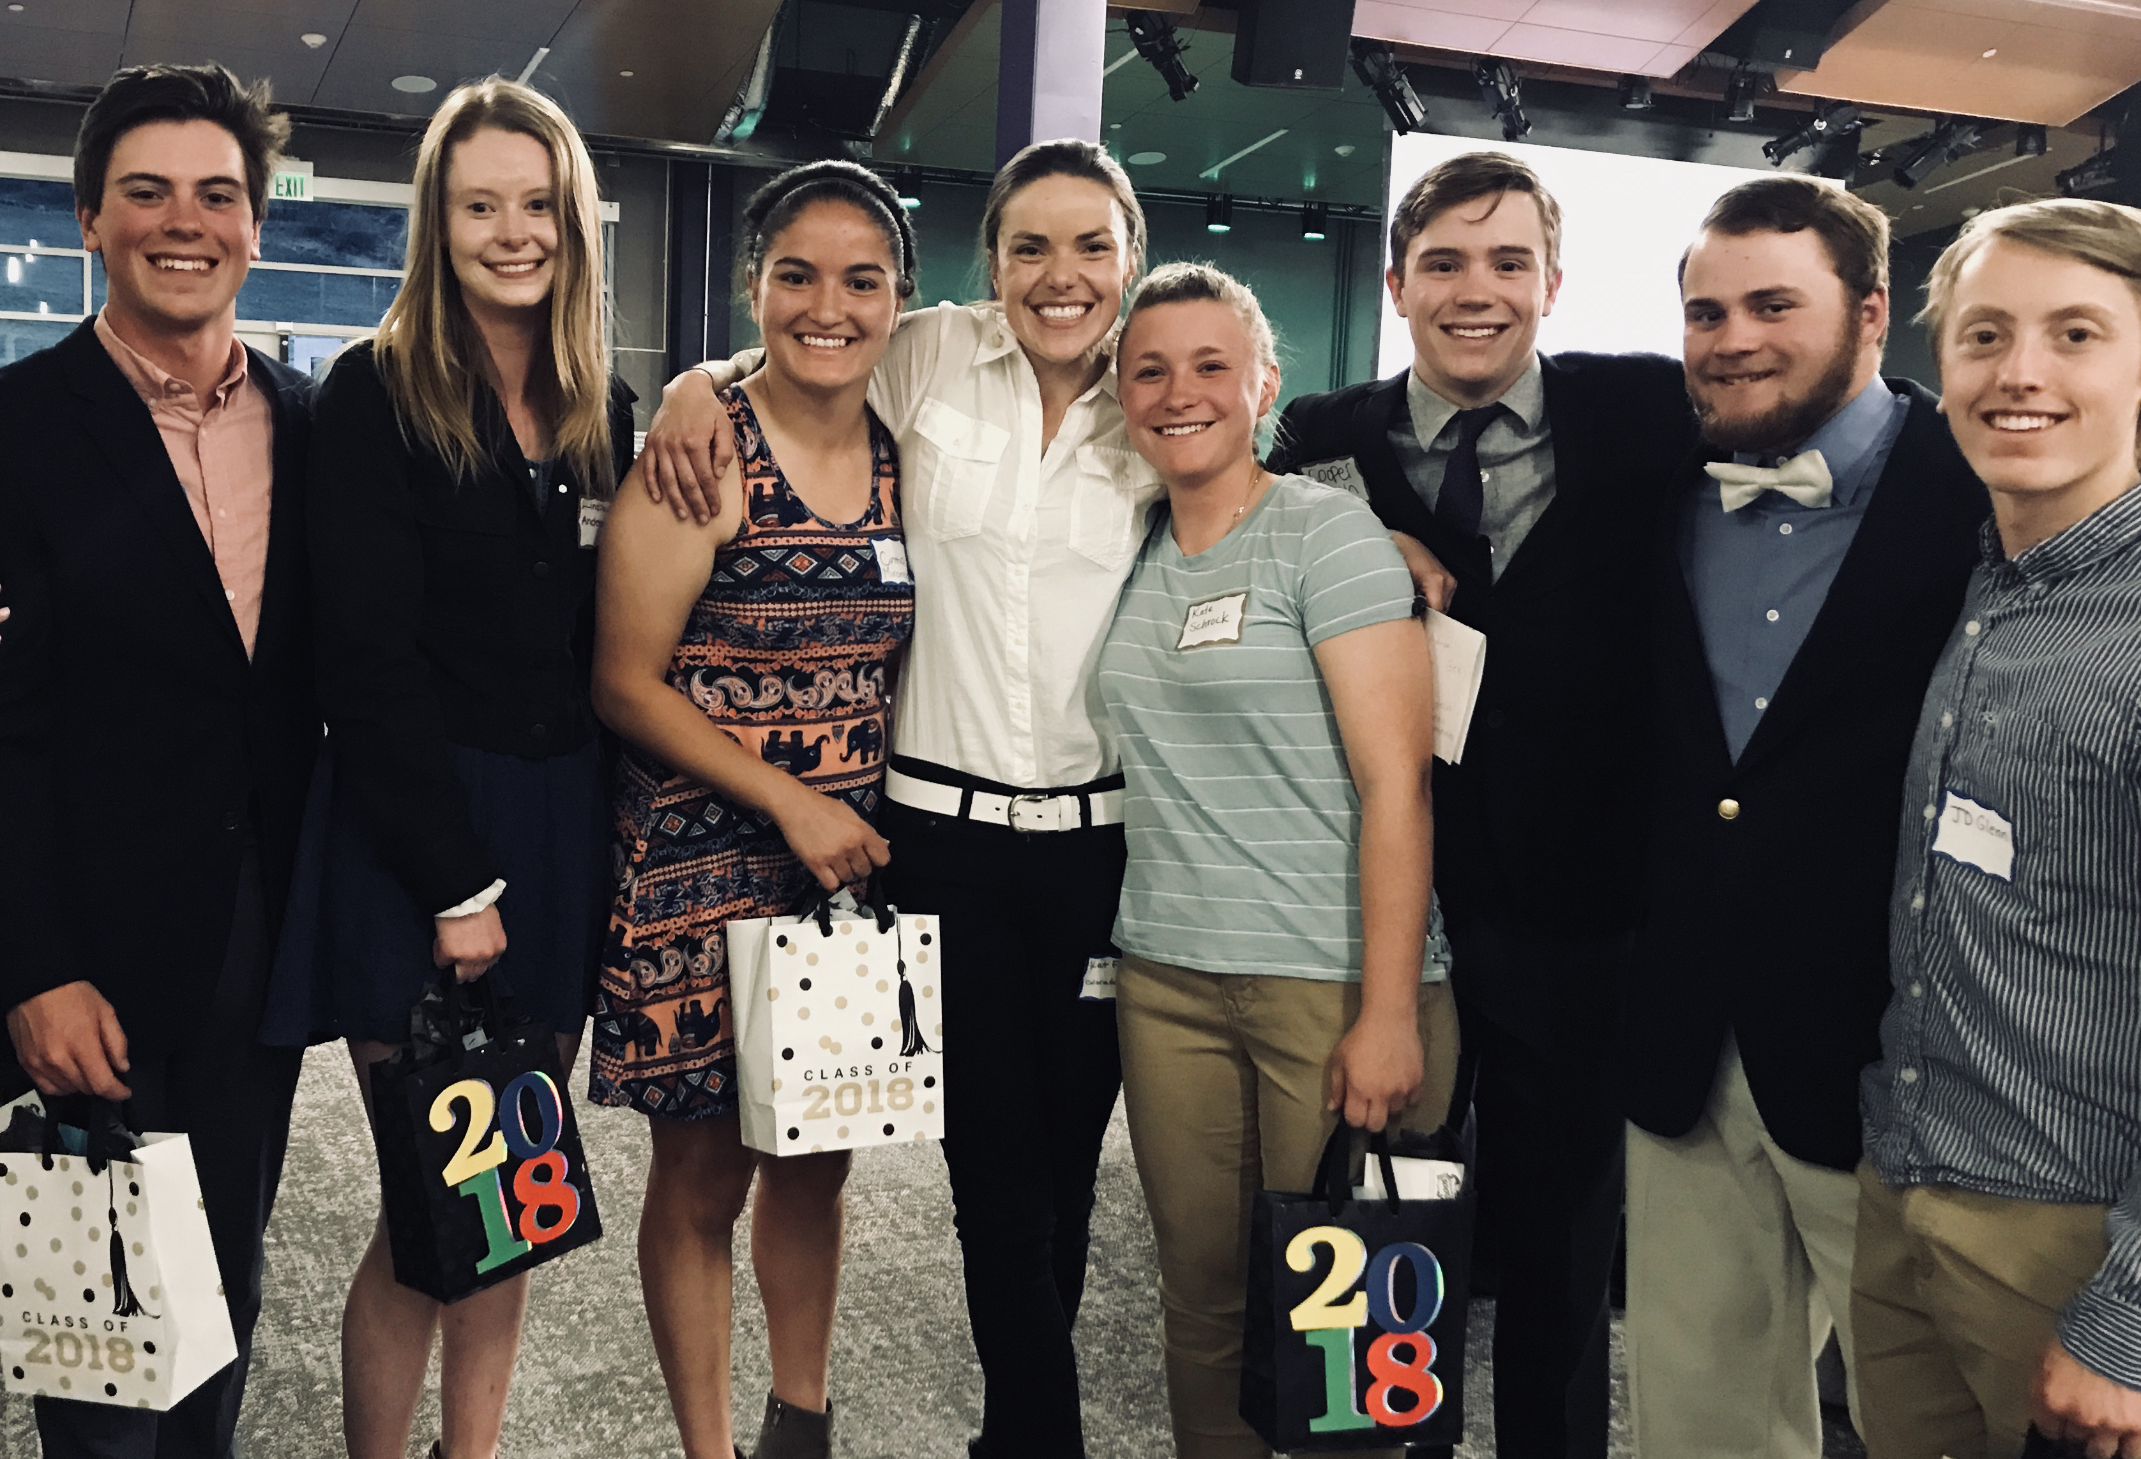
$31,500.00 in College Scholarships was granted to Basalt High School Graduates Class of 2018!
Left to right: Griffen Jenkins, Lindsay Anderson, Cintia Miramontes, former recipient & presenter Kat Fitzpatrick,
Kate Shrock, Cooper Braun, Thomas Wirth, and John (J.D.) Glenn. Special thanks to Sumner McKnight, Gaston Family, Chip Griffith, New England Rough Riders, Team Texas and Colorado 500 Alumni for the generous scholarship funding!

$1,500.00 | Basalt Elementary
$1,500.00 | Basalt High School
$300.00 | Basalt High School Project Graduation
$1,500.00 | Basalt Middle School
$500.00 | Grace Church Basalt
$750.00 | Beta Chi Sorority
$1,000.00 | Stepping Stones, for Patrick’s Place
$150.00 | Roaring Fork Conservancy  Frying Pan River Clean Up
$3,000.00 | Roaring Fork Conservancy  Basalt Fire Fighters Fund
$1,500.00 | Crested Butte Community Schools
$1,500.00 | Crested Butte Search & Rescue
$1,500.00 | Ouray Ambulance
$1,500.00 | Ouray Community Schools
$1,500.00 | Ouray Mountain Rescue
$1,500.00 | Hinsdale Cty. EMS
$500.00 | Haven House, Montrose
1,500.00 | Dolphin House, Ouray
$500.00 | Tri-County Resources
$1,500.00 | Lake City Medical Center
$1,500.00 | Lake City School K-12
$500.00 | Gunnison 4H Club
$1,500.00 | Silverton Public Schools
$1,000.00 | Gunny/CB Goats
$1,000.00 | San Juan Trail Riders
$1,500.00 | Fragile Kids Foundation
$1,000.00 | Samaritans Purse
$2,000.00 | Colin Collins Memorial Award to disabled veteran: Chris Santistevan
$10,900.00 | Colorado 500 Ministries
$2,145.00 | COHVCO matching funds
$11,663.65 | Continuing prior scholarship grants
$3,672.82 | Balance for Keith Harrison’s wheelchair
$93,000.00 | TOTAL DONATIONS MADE 2018

